TASK 4 – SETTING UP JAVA & MAVEN

**Objective**

1. Configure environment variables for Java and Maven on a local system.
2. Validate the setup by building a sample Maven project.

**Prerequisites**

* Windows 11 operating system.
* Installed Java Development Kit (JDK) version 8 or later.
* Installed Apache Maven.
* Command Prompt access.
* Internet connection

**Java**

Java is a programming language and runtime environment essential for running Java-based applications. In this task, Java is required to compile and run Maven projects.

* **Role in the Task**:  
  Java provides the development environment (JDK) necessary for compiling code and running Java-based tools like Maven.
* **Key Commands**:
  + java -version: Verify the installed Java version.

**Maven**

Apache Maven is a build automation tool used for managing project dependencies, building projects, and automating testing.

* **Role in the Task**:  
  Maven simplifies project setup and management by automating dependency resolution, compiling code, and packaging it into distributable formats (like JAR files).
* **Key Commands**:
  + mvn -version: Verify the installed Maven version.
  + mvn clean install: Cleans previous builds and compiles the project to generate an artifact (e.g., JAR file).
  + mvn archetype:generate: Creates a new Maven project structure.

**Why Java and Maven are Linked**

Maven relies on Java to execute its tasks, as it is written in Java and uses the Java Development Kit (JDK) during project compilation and execution. Proper configuration of Java is essential for Maven to function effectively.

LOG IN TO JENKINS

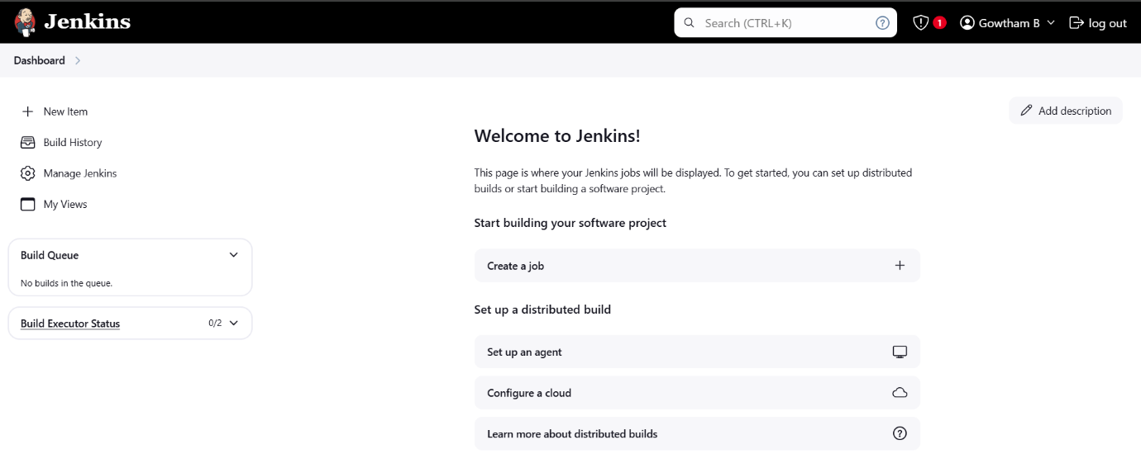

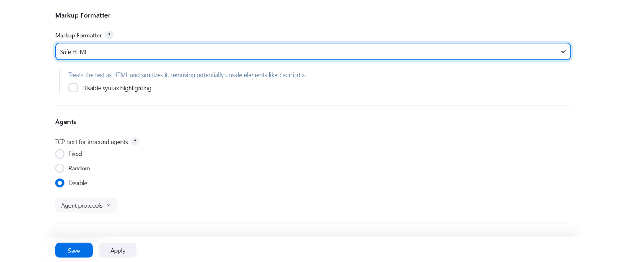

WINDOWS IP CONFIGURATION

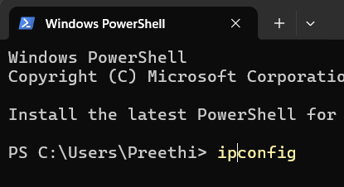

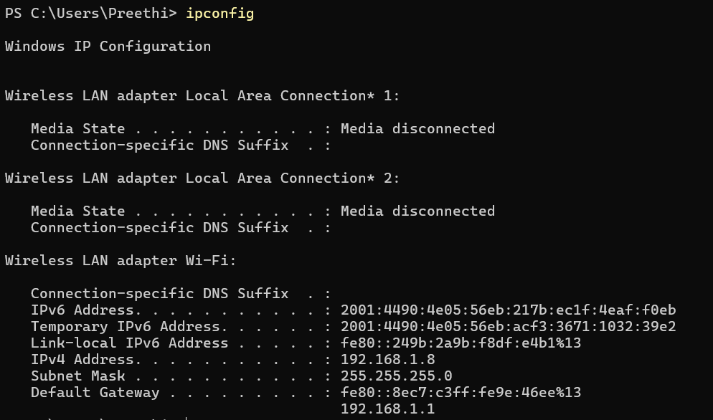

SETTING PATHS

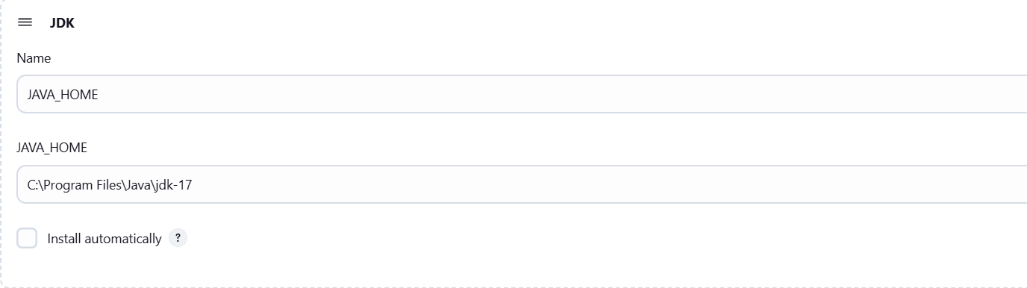

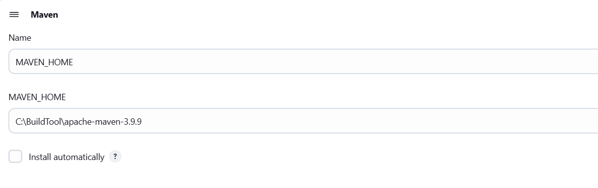

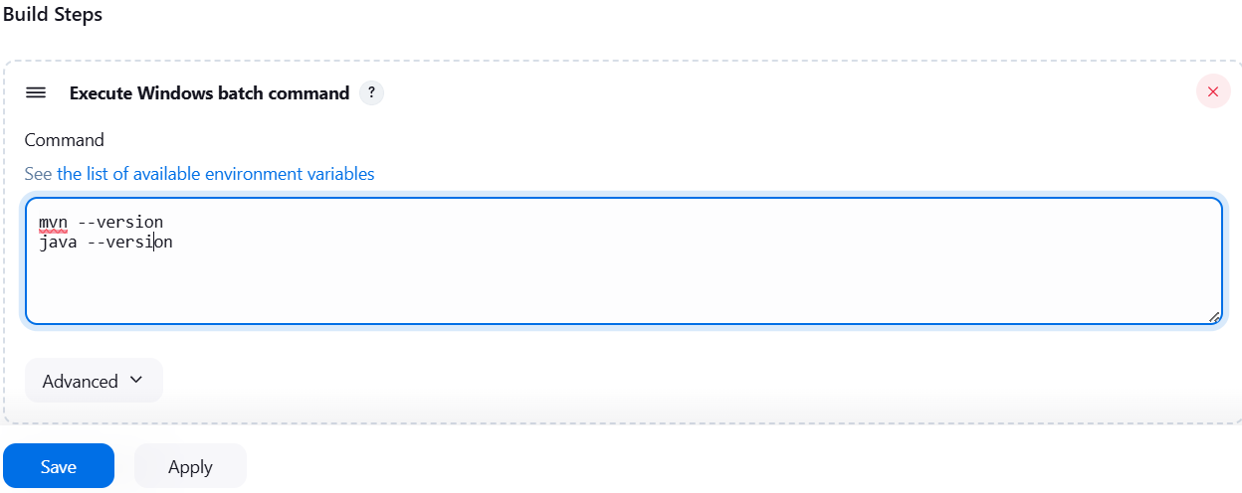

BUILD PHASE

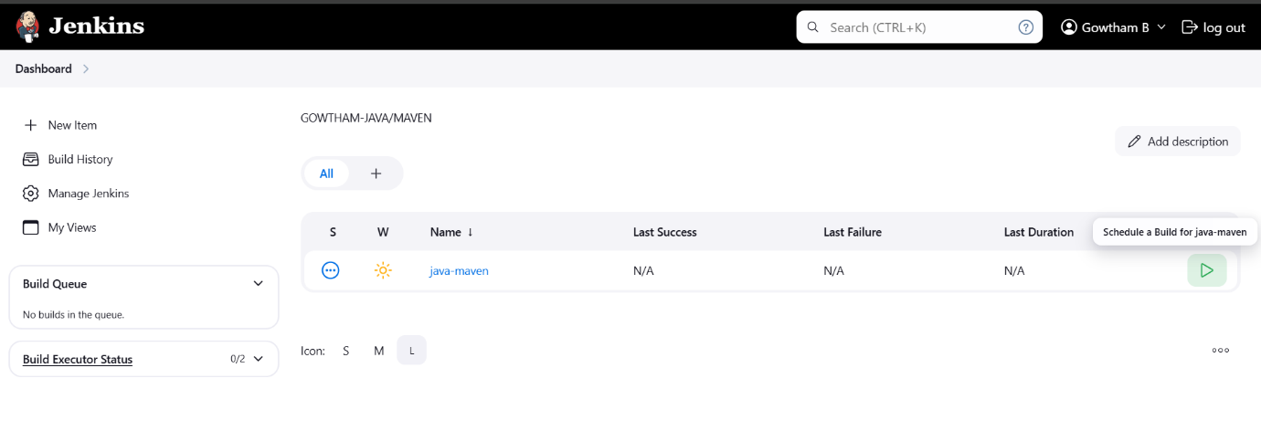

BUILD SUCCESSFUL

